Title: HEATHENS & THE HOLY: Examining conjectural archaeological evidence of pagan or Christian practice at St.Baldred’s Cave
Amber Hunt, Archaeology Department (Medieval and Post-Medieval MA Strand), Durham University, smrf33@durhm.ac.uk/ amberlhunt@yahoo.co.uk
Abstract
The acknowledgement of caves within the world of medieval archaeology is steadily gaining traction, especially due to the research of scholars such as Marion Dowd and Knut Bergsvik. This article aims to exemplify the importance of cave archaeology pertaining to the middle ages and their role as conduits for religion, ritual and conversion. It shows how certain topographies retain elements of sacrality but with changing faces, however, the connection between man and landscape is something that has been renegotiated but retained from late prehistory into the late middle ages. The case-study of the under researched St Baldred’s Cave is used to exemplify this.
Keywords: Pagan; Christian; Ritual; Early Medieval; Cave Archaeology
Main article
British early medieval caves are a neglected archaeological field, with most sites gaining attention due to Palaeolithic interest. Accordingly, many of these sites, which are now recognised for their later bibliographies and possible medieval utility, have much of their stratigraphy destroyed and dug through (Bergsvik and Dowd, 2018, p. 1). Focusing on these sites for their historic reuse and reverence throughout time can contribute greatly to understanding how people interacted with the landscape; it can also offer perspectives on the role these locations played in pre-Christian and Christian societies, as Marion Dowd has exemplified in Ireland (2018).
To illustrate the importance of this overlooked field, the case-study of St Baldred’s Cave is employed for its historical omission, possibly due to the change in names from Seacliff Cave to St Baldred’s (Layard, 1934, p. 400), and the failure of archaeologists and historians to revisit this site. The cave appears, hitherto, to have been last visited over 80 years ago by Nina Layard (1934), with excavations conducted over 160 years ago by George Sligo (1858) only being mentioned in passing. St Baldred’s Cave is located at the base of a rocky outcrop on the coast of Seacliff, Scotland. Its namesake is the 8th century Northumbrian hermit, Saint Baldred (or Balther) of Tyninghame. St Baldred is a lesser known saint with heroic tales of miraculously removing reefs that likely prevented seafarers from accessing the beach and hindering trade (Farmer, 2011, p. 34). This is more pertinent when considering Tyninghame from which he hailed in 756 and gave his name to the chapel there, also had an important monastery (HES, 1987) which likely took advantage of coastal trade.
Sligo documents his encounter with the cave in 1831 when he hired workmen to clear the sand that had blown onto the grass banks from the beach, only then was the cave revealed (1858, pp. 353–354). The cave is 20ft at its highest point, receding backwards, just over 29ft, to a hight of 3ft with a mostly paved ground (Sligo, 1858, pp. 354–355). Sligo speculates the cave’s soft sandstone had been altered to form an arched roof and entrance to the right of an alter that stands in the centre, towards the opening (see figure 2) (1858, pp. 354–355). The ‘alter’ (identified as ‘A’ in figure 1) is formed from one stone (Sligo, 1858, p. 355); however, due to concerns of its weakened base, Sligo had one of the supporting rocks removed, intending to replace it with a larger stone, when to the north fell a skeleton of a 6 to 8 month old infant (Sligo, 1858, p. 355; Layard, 1934, p. 400).
A second infant was found nearby (Sligo, 1858, p. 355), unfortunately both sets of remains are undated, however, an assumption of their period can be theorised by reason of later prehistoric pottery found within the same context (Hume and Armit, 2024, p. 6). Sligo notes the workmen removing ‘quantities’ of bone and charcoal, indicating a subpar method of excavation compared to modern standards (1858, p. 354). Nonetheless, other human bones were found, accompanying horse, sheep, pig and dog remains (Layard, 1934, p. 399). The only tools reported were an animal tusk used as a knife and red earthenware (Layard, 1934, p. 400). To surmise, a combination of the place-name and associated saintly activity with the later prehistoric archaeological evidence, indicates the revival, reuse or ‘renegotiation’ of a once pre-Christian site into a location now renowned for its ecclesiastical connections with an early hermit (Semple, 2010, p. 40).
This combination certainly attests to some form of reuse, whether intentional or not is purely speculative, however, St Baldred’s Cave seems to have conjured significance for different peoples and purposes. This is similar to what Sarah Semple has mentioned regarding temples and shrines, and how, sometimes, their archaeological evidence alludes to the ‘renegotiation’ of an area for a ‘successive audience’, thus accumulating different meanings and roles in their societies (2010, p. 40). This kind of reuse possibly resulted in what Semple calls a ‘communal identity’ whereby memories and an awareness of historic activity in a location has helped create an intrinsic connection between the surrounding inhabitants and the landscape (Semple, 2010, p. 42); this, as Semple says, cultivates an essence of ‘legitimacy’ over a region or area (2010, p. 42). Sam Wilford also touches on this theory, specifying that coastal bay caves and other locations which constitute a feature in the landscape may symbolise a transitional area, or liminal zone, between the ‘familiar and unfamiliar’ (Wilford, 2016, p. 230); Wilford ties this into the overarching concept of a ‘communal identity’ where a ‘topophilic’ bond with a region materialises (Semple, 2010, p. 42; Wilford, 2016, p. 231). Accordingly, this theory may have been how this particular cave continued to hold relevancy in the minds of local societies throughout history, up until its introduction to Christianity. The conceivable knowledge, or even esoteric awareness, of the hereditary pre-Christian sacrality of St Baldred’s Cave may have been what drew Christian attention to it. When researching caves in Ireland, many of which are also names after saints, Dowd theorises that the Church ‘saved’ caves known to be important in ‘pagan’ tradition (2015, p. 176). She notes how Christians found biblical relations to caves, likely through the practices of Egyptian desert fathers and their hermit lifestyle, or a saintly association, or renowned event; therefore, Christians saw it as part of their conversion mission to enlighten these pagan places and convert them into holy sites (Dowd, 2015, p. 176). Ergo, the caves Christians converted must have been known for their non-Christian reverence and activity, otherwise they would not have been recognised. Subsequently, it is clear cave sites ought to be given more acknowledgment within the sphere of medieval archaeology due to their strong pre-Christian links that continued through the conversion period and into the later Middle Ages. With more concentration on these locations, more knowledge of pre and early Christian religion and topographic relations with society can be discovered.
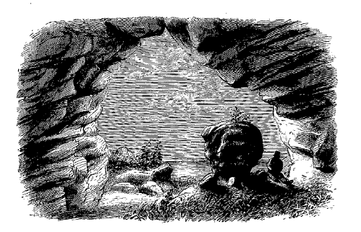
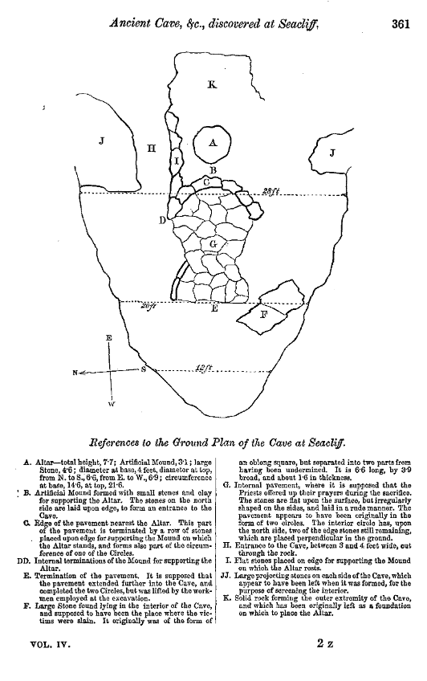
Figure 2 Image of St Baldred's cave, specifically the ‘alter’ (view from the interior outwards) (Sligo, 1858, p.357)
Figure 1 Ground plans of St Baldred's cave (Sligo, 1858, p.361)
BIBLIOGRAPHY:
Bergsvik, K. and Dowd, M. (2018) ‘Caves and Rockshelters in Medieval Europe’, in Caves and Ritual in Medieval Europe, ad 500-1500. 1st edn. Oxbow Books, Limited, p. 323. Available at: https://ebookcentral.proquest.com/lib/durham/detail.action?docID=5260116&pq-origsite=primo (Accessed: 4 November 2023).
Dowd, M. (2015) The Archaeology of Caves in Ireland. Havertown, UNITED STATES: Oxbow Books, Limited. Available at: http://ebookcentral.proquest.com/lib/durham/detail.action?docID=2167185 (Accessed: 6 November 2023).
Dowd, M. (2018) ‘Saintly associations with caves in Ireland from the early medieval period (AD 400-1169) through to recent times’, in Caves and Ritual in Medieval Europe, AD 500-1500. 1st edn. Oxbow Books, Limited, p. 323. Available at: https://ebookcentral.proquest.com/lib/durham/detail.action?docID=5260116&pq-origsite=primo.
Farmer, D.H. (2011) The Oxford dictionary of saints. New York, NY : Oxford University Press. Available at: http://archive.org/details/oxforddictionary0000farm_d0b7 (Accessed: 16 June 2024).
HES (1987) TYNINGHAME (GDL00380), Historic Environment Scotland. Available at: https://portal.historicenvironment.scot/designation/GDL00380 (Accessed: 16 June 2024).
Hume, B. and Armit, I. (2024) ‘A Light in Dark Places: Later Prehistoric Mortuary Activity in Caves in Scotland and Northern England’, Proceedings of the Prehistoric Society, pp. 1–19. Available at: https://doi.org/10.1017/ppr.2024.7.
Layard, N.F. (1934) ‘Evidence of Human Sacrifice in Seacliff Cave, Scotland’, Proceedings of the Prehistoric Society of East Anglia, 7(3), pp. 399–401. Available at: https://doi.org/10.1017/S0958841800026934.
Semple, S. (2010) ‘In the Open Air’, in Signals of Belief in Early England : Anglo-Saxon Paganism Revisited. 1st edn. Oxbow Books, Limited, p. 229. Available at: https://ebookcentral.proquest.com/lib/durham/detail.action?docID=1165967.
Sligo, G. (1858) ‘Notes on an Ancient Cave, &c., discovered at Aldham, now called Seacliff, in East Lothian, in 1831’, Archaeologia Scotica, 4, pp. 353–361.
Wilford, S. (2016) Riddles in the Dark? The human use of caves during the 1st millennia BC and AD across the British Isles. Thesis. Durham University. Available at: https://etheses.dur.ac.uk/11905/1/Wilford_Riddles.pdf?DDD6+ (Accessed: 19 April 2024).

