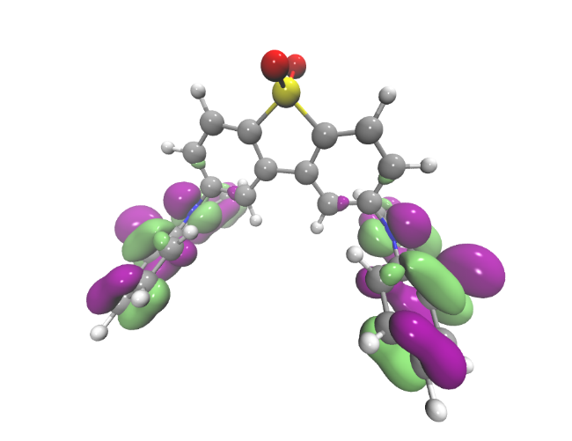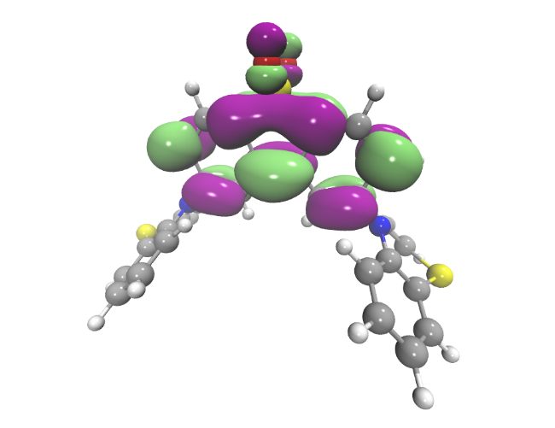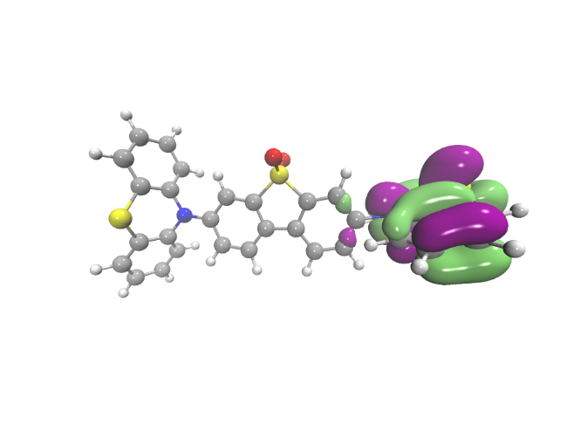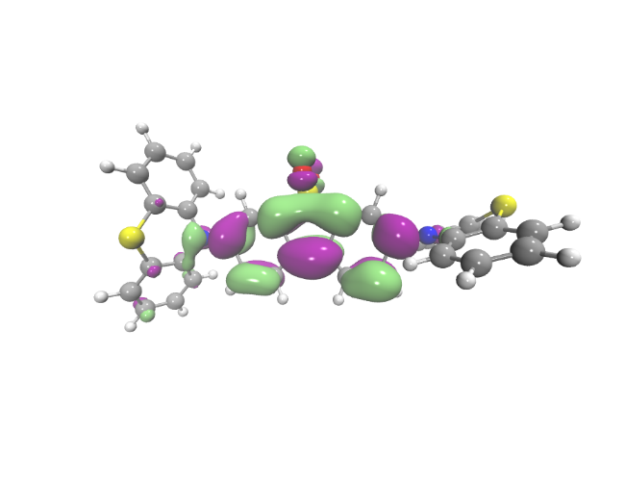
Supplementary Figure 1| Density Functional Theory calculations of the HOMO and LUMO orbitals on the isomers. (a) HOMO of MA (b) LUMO of MA (c) HOMO of MB (d) LUMO of MB.

Supplementary Figure 2| Cyclic voltammetry of investigated compounds MA and MB at 1 mM concentration (a) in 0.1M Bu₄NBF₄/DCM. (b) Comparison of CV curve up to first and second oxidation potential of MB. Measurement conditions: scan rate 50 mV/s, Ag/AgCl – quasi-reference electrode, calibrated against a ferrocene/ferrocenium redox couple.

Supplementary Figure 3|

Supplementary Figure 4|

Supplementary Figure 5|

Supplementary Figure 6| High concentration band edge absorption as a function of solvent. (a) The band edge absorption of MA in a variety of solvents at 1 mM concentration. The hypsochromic shift unveils the n-π* nature of the low energy absorption in this molecule. (b) Conversely for MB at 1 mM concentration there is no significant shift in the absorption thus emphasising the mixed nature of the absorption in this system.

Supplementary Figure 7| MB absorption as a function of solvent polarity

Supplementary Figure 8| The effect of solvent polarity on the absorption and emission of MA. (a) The ground-state absorption of MA as a function of solvent polarity. (b) The emission of MA as a function of solvent polarity showing a clear bathochromic shift.

Supplementary Figure 9| Degassed versus non-degassed solutions of MA in MCH (a) Comparison of intensities of degassed (black solid line) versus non-degassed (blue dashed line) indicating the ratio of 11 between the two conditions. (b) The normalised emissions to indicate that they are the same spectral shape.

Supplementary Figure 10| Degassed versus non-degassed solutions of MA in MCH (a) Comparison of intensities of degassed (black solid line) versus non-degassed (blue dashed line) indicating the ratio of 2.5 between the two conditions. (b) The normalised emissions to indicate that they are the same spectral shape

Supplementary Figure 11| The absorption of the two isomers in a zeonex matrix host

Supplementary Figure 12|Comparison of the degassed and non-degassed emission of the isomers in a zeonex host. (a) Emission of MA in zeonex as a function of oxygen. The difference between the two spectra clearly shows higher onset emission than ¹CT which is attributed to ³LE. (b) Emission of MB in zeonex as a function of oxygen with the CT_{ax} emission observed at onset ca. 3 eV and also the contribution of ³LE giving a higher onset than the expect 2.50 eV for CT_{eq}.

Supplementary Figure 13|Energy level schematic for the TADF mechanism. Two energy level orderings for the TADF mechanism showing Type I, where ¹CT>³LE, on the left-hand side (LHS) and Type III, where ¹CT<³LE, on the right-hand side (RHS). These mechanisms are presented completely in previous work; from which we use the notation.¹ Type II TADF is where the ³LE and ¹CT are considered isoenergetic.

Supplementary Figure 17| Comparison of prompt fluorescence and delayed fluorescence of MA and MB in MCH. (a) The prompt fluorescence (PF) and delayed fluorescence (DF) of MA match in terms of their spectral shape. (b) This is similarly shown for MB.

Supplementary Figure 18| Excitation intensity dependence of MA and MB in zeonex films. (a) The change in spectra of MA with increasing intensity and the linear power dependence on intensity indicating TADF. (b) Similarly for MB. The spectra are plotted as a function of wavelength and have not been corrected using to the Jacobian in Mooney and Kambhampati,² as the integral of the emission versus power is the focus. Spectra were acquired with 1 µs delay time and integrated for 200 µs.

Supplementary Figure 19| Theoretical calculations of the rISC rate as a function of conformer and 3 vs 4 state coupling (a) The riSC rate in the two isomers, showing that MA is twice as efficient at rISC compared to MB. (b) Comparing the 3 and 4 state model showing that there is minimal change with the consideration of a fourth state.

Supplementary Figure 20| Emission decay profiles of a MA and MB in a variety of solid state hosts as a function of temperature. (a) MA in CBP where the rigidity of the matrix prevents change in the ΔE_{S-T} gap and thus prompt CT_{eq} lifetime (<10² ns) remains unchanged. (b) MA in PEO, which has a diminishing ΔE_{S-T} gap with increasing rigidity and decreasing temperature, thus the prompt CT_{eq} lifetime increases with decreasing temperature. (c) MB in CBP, where the rigidity of the matrix prevents change in the ΔE_{S-T} gap and the lifetime remains unchanged. (d) MB in Zeonex, which is more rigid than PEO but less rigid than CBP and as such there is minimal change in ΔE_{S-T} and thus prompt CT_{eq} lifetime. The red lines are the exponential fits to the data, the parameters of which can be found in Supplementary Tables X-Y.

Supplementary Figure 21| Decay lifetimes of MA and MB in a variety of solid state hosts as a function of temperature. (a) MA in CBP, where the rigidity of the matrix means that there is no change in the energy gap and thus no change in lifetime. (b) MA in PEO, where the change in energy gap with temperature means that there is an increase in the lifetime of the prompt and delayed CT_{eq} emission. This agrees with the resonance curves published in previous work. The prompt LE lifetime remains unchanged however as this is not affected by rISC rate. (c) MB in CBP, where the rigidity of the matrix again prevents any change in the lifetime. The variation in the delayed fluorescence lifetime of CT_{eq} is due to the early onset of a power law decay in the data. This can skew the exponential fit and thus the uncertainty in those values is much larger than the error bars. (d) MB in Zeonex, where even though the matrix is not as rigid as CBP there is very minimal change in the lifetimes of the species. The error bars are the error on the fit and do not consider any uncertainty on whether the decay is exponential or power law.

Supplementary Figure 22| Time-resolved emission spectra of MA and MB in CBP (a) The time-resolved (TR) spectra of MA in CBP shows ¹LE character at early times, which then becomes completely ¹CT_{eq} by 15 ns onwards. (b) the TR spectra of MB in CBP shows a combination of ¹CT_{ax} and ¹CT_{eq} that becomes purely ¹CT_{eq}. This is indicated by the spectra shift to lower energies within 10 ns, and is corroborated in the emission decay fits (Supplementary Table X).

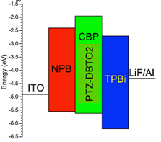
Supplementary Figure 23| The structure and electroluminescence of MA and MB in devices. (a) The typical device structure used for the MA and MB devices. (b) The electroluminescence spectra of the MA and MB devices showing that just as in the photoluminescence MB is still redder in emission than MA.

Supplementary Figure 24| Device characteristics of the isomers in a DPEPO host device. (a) The J-V curves of the devices. (b) EQE vs brightness for the devices. (c) Comparison of the electroluminescence for the devices at the same current density.

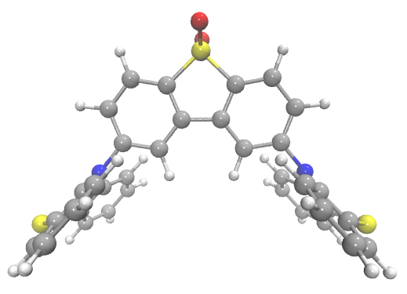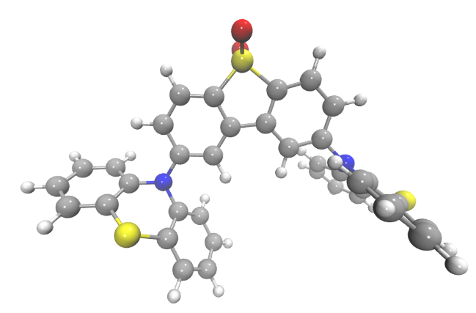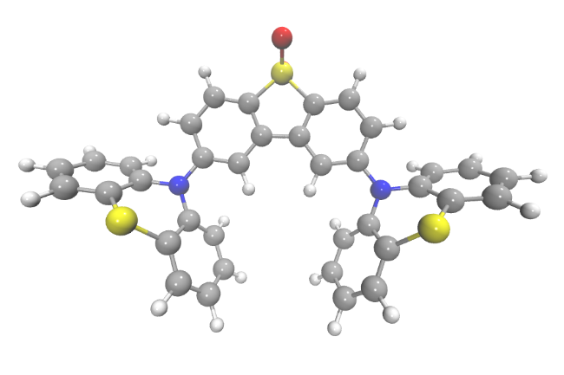
Supplementary Figure 25| Possible conformations of the MA isomer (a) ax-ax (b) eq-ax (c) eq-eq.

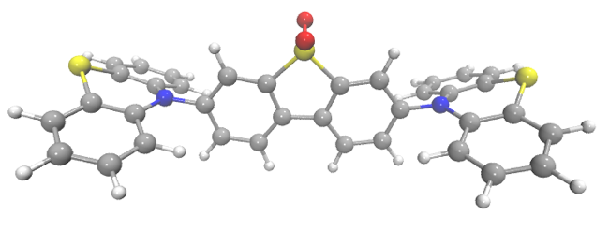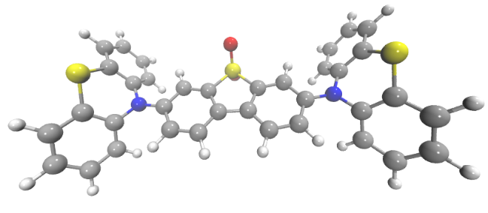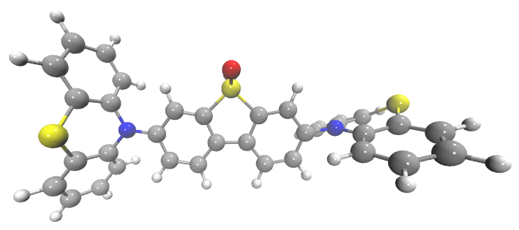
Supplementary Figure 26| Possible conformations of the MB isomer (a) ax-ax (b) eq-eq (c) eq-ax

Supplementary Table 1| Electrochemical HOMO and LUMO energies
Compound | HOMO (eV) | LUMO (eV)
MA | -5.45 | -3.05
MB | -5.40 | -3.05

Supplementary Table 2| Spectroscopic properties of investigated compounds in neutral and in charged states.
 | Neutral state |  | Absorption bands [nm] |  |  |  | g-value
compound | λ_{max}[nm] | E_{g}^{opt} [eV] | oxidized state
(MB) | 396 | 2.82 | 276 | 345 | 396 | 518 | 2.00565
(MA) | 336 | 3.37 | 276 |  | 516 |  | 2.00549

Supplementary Table 3|
 | Absorption bands [nm] |  | g-value
compound | Reduced state
(MB) | 254 | 329 | 2.00236
(MA) | 254 | 328 | 2.00238

Supplementary Table 4| Relative energies of the 3 conformers of MA and MB and the prevalence of each structure calculated using a Boltzmann distribution. The energetics have been calculated using a DFT(PBE0) optimised geometry and a polarisable continuum model with the dielectric constant of water.

 | Relative Energy (eV) | % conformer
MA axial-axial | 0.38 | 0.00
MA axial-equatorial | 0.07 | 0.05
MA equatorial -equatorial | 0.00 | 0.95
MB axial-axial | 0.09 | 0.02
MB axial-equatorial | 0 | 0.93
MB equatorial -equatorial | 0.07 | 0.05

Supplementary Table 5| Parameters for the 3 state D-A model Hamiltonian of MA described above. These have been previously published in ref.³

Parameter | Value (cm-1)
ω1 | 13.61
ω11 | 173.65
ω23 | 422.60
E_{SOC} | 2.00
E_{HFI} | 0.20
Relative Energy ³LE_{D} | 0.00
Relative Energy ³CT | 0.01
Relative Energy ¹CT | 0.04
λ1 | 67.02 (³CT-³LE_{D})
λ11 | 91.71 (³CT-³LE_{D})
λ23 | 79.04 (³CT-³LE_{D})

Supplementary Table 6| Parameters for the 4 state D-A model Hamiltonian of MA Hamiltonian described above.

Parameter | Value (cm-1)
ω1 | 13.61
ω5 | 84.60
ω9 | 128.32
ω11 | 173.65
ω23 | 422.60
Relative Energy ³LE_{D} | 0.00
Relative Energy ³LE_{A} | 0.14
Relative Energy ³CT | 0.02
Relative Energy ¹CT | 0.05
E_{SOC} | 2.00
E_{HFI} | 0.20
λ1 | 67.02 (³CT-³LE_{D}) 143.00, (³CT-³LE_{A})
λ11 | 91.71 (³CT-³LE_{D}) 75.65 (³CT-³LE_{A})
λ23 | 79.04 (³CT-³LE_{D}) 75.65 (³CT-³LE_{A})
λ5 | 91.78 (³CT-³LE_{A})
λ9 | 183.89 (³LE_{D}-³LE_{A})

Supplementary Table 7| Parameters for the 3 state D-A model Hamiltonian of MB described above.

Parameter | Value (cm-1)
ω2 | 13.61
ω9 | 173.65
ω12 | 422.60
Relative Energy ³LE_{D} | 0.06
Relative Energy ³CT | 0.00
Relative Energy ¹CT | 0.03
E_{SOC} | 2.00
E_{HFI} | 0.20
λ2 | 216.07 (³CT-³LE_{D})
λ9 | 112.75 (³CT-³LE_{D})
λ12 | 169.53 (³CT-³LE_{D})

Supplementary Table 8| The exponential decay fitting parameters of the MA in CBP film time-resolved emission
Temperature (K) | $$A_{LE}^{PF}$$ | $τ_{LE}^{PF}$ (ns) | $$A_{{CT}_{eq}}^{PF}$$ | $τ_{{CT}_{eq}}^{PF}$ (ns) | $$A_{{CT}_{eq}}^{DF}$$ | $τ_{{CT}_{eq}}^{DF}$ (ns)
298 | 4.3±0.3E6 | 5.2±0.3 | 4.2±0.4E5 | 46±4 | 3.9±0.2E4 | 6.0±0.6E3
220 | 4.97±0.09E6 | 5.1±0.1 | 4.4±0.3E5 | 41±2 | 2.3±0.1E4 | 7.7±0.6E3
160 | 3.44±0.07E6 | 5.7±0.2 | 5.0±0.2E5 | 43±1 | 6.8±0.4E3 | 1.2±0.2E4
100 | 5.32±0.06E6 | 4.13±0.09 | 4.5±04E5 | 42±4 | 2.3±5.3E3 | 7.5±7.5E3
80 | 6.8±0.2E6 | 3.06±0.09 | 6.1±0.2E5 | 43±1 | 6.0±1.6E2 | 1.6±1.0E4

Supplementary Table 9| The exponential decay fitting parameters of the MA in PEO film time-resolved emission
Temperature (K) | $$A_{LE}^{PF}$$ | $τ_{LE}^{PF}$ (ns) | $$A_{{CT}_{eq}}^{PF}$$ | $τ_{{CT}_{eq}}^{PF}$ (ns) | $$A_{{CT}_{eq}}^{DF}$$ | $τ_{{CT}_{eq}}^{DF}$ (ns)
275 | 2.4±0.1E7 | 7.6±0.4 | 1.4±0.1E7 | 20.9±0.7 | 1.44±0.07E5 | 958±59
250 | 2.73±0.09E7 | 7.1±0.4 | 2.95±0.09E7 | 29.0±0.5 | 5.5±0.1E5 | 1.70±0.6E3
225 | 5.0±0.2E7 | 5.6±0.3 | 3.3±0.1E7 | 34.9±0.8 | 9.1±0.3E5 | 3.5±0.2E3
200 | 5.2±0.2E7 | 6.4±0.4 | 3.0±0.1E7 | 38±1 | 9.1±0.3E5 | 5.3±0.3E3
175 | 4.9±0.1E7 | 8.4±0.4 | 2.19±0.09E7 | 47±1 | 6.2±0.2E5 | 8.4±0.5E3
150 | 5.1±0.1E7 | 6.5±0.3 | 2.17±0.07E7 | 46±1 | 4.6±0.2E5 | 8.9±0.6E3
80 | 3.88±0.09E7 | 7.2±0.3 | 1.65±0.05E7 | 57±1 | 1.12±0.08E5 | 1.4±0.2E4

Supplementary Table 10| The exponential decay fitting parameters of the MB in CBP film time-resolved emission
Temperature (K) | $$A_{LE}^{PF}$$ | $τ_{LE}^{PF}$ (ns) | $$A_{{CT}_{ax}}^{PF}$$ | $τ_{{CT}_{ax}}^{PF}$ (ns) | $$A_{{CT}_{eq}}^{PF}$$ | $τ_{{CT}_{eq}}^{PF}$ (ns) | $$A_{{CT}_{eq}}^{DF}$$ | $τ_{{CT}_{eq}}^{DF}$ (ns)
300 | 8.3±0.5E8 | 1.50±0.09 | 2.3±0.1E8 | 6.5±0.3 | 2.3±0.4E7 | 23±2 | 5.9±0.2E5 | 2.5±0.2E3
290 | 5.2±0.2E8 | 1.78±0.10 | 1.6±0.1E8 | 6.8±0.4 | 1.3±0.2E7 | 25±2 | 4.1±0.2E5 | 2.4±0.2E3
230 | 6.80±0.06E8 | 1.27±0.02 | 2.26±0.03E8 | 4.46±0.06 | 4.3±0.1E7 | 15.4±0.2 | 4.9±0.2E5 | 874±85
150 | 6.20±0.1E8 | 1.78±0.05 | 1.36±0.06E8 | 6.9±0.2 | 1.7±0.1E7 | 23.9±0.8 | 9.5±0.5E4 | 3.2±0.3E3
80 | 7.1±0.1E8 | 1.53±0.03 | 1.58±0.05E8 | 5.8±0.1 | 2.12±0.08E7 | 22.0±0.3 | 8.0±0.6E3 | 1.4±0.2E4

Supplementary Table 11| The exponential decay fitting parameters of the MB in zeonex film time-resolved emission
Temperature (K) | $$A_{{CT}_{ax}}^{PF}$$ | $τ_{{CT}_{ax}}^{PF}$ (ns) | $$A_{{CT}_{eq}}^{PF}$$ | $τ_{{CT}_{eq}}^{PF}$ (ns) | $$A_{{CT}_{eq}}^{DF}$$ | $τ_{{CT}_{eq}}^{DF}$ (ns)
290 | 4.24±0.04E8 | 3.32±0.06 | 3.9±0.5E7 | 9.4±0.4 | 9.0±0.5E4 | 1.3±0.2E4
230 | 8.22±0.05E8 | 4.02±0.03 | 2.6±0.2E7 | 15.3±0.6 | 8.7E4±0.6E4 | 1.5±0.2E4
150 | 9.85±0.07E8 | 3.62±0.04 | 5.2±0.5E7 | 12.2±0.4 | 3.9±0.5E4 | 9.0±0.3E4
80 | 6.77±0.03E8 | 4.53±0.03 | 2.1±0.1E7 | 17.7±0.5 | 3.9±0.8E3 | 3.5±1.9E4

Supplementary Table 12| Computational details for the MCTDH simulations. Ni is the number of primitive harmonic oscillator discrete variable representation (DVR) basis functions used to describe each mode. n_{i} are the number of single-particle functions used to describe the wavepacket.

Simulation | Modes | N_{i} | n_{i}
ISC MA | ν1 | 21 | 12,12,12
(3 state) | ν11,ν23 | 21 | 12,12,12
rISC MA | ν1 | 21 | 21,61,31
(3 state) | ν11,ν23 | 21 | 12,12,12
ISC MA | ν1,ν11 | 21 | 3,19,19,13
(4 state) | v9,ν23  v5 | 21  21 | 3,19,19,13  3,11,11,11
rISC MA | ν1,ν11 | 21 | 21,61,31
(4 state) | v9,ν23  v5 | 21  21 | 21,61,31  12,12,12
ISC MB | ν2,ν9 | 21 | 12,12,12
 | ν22 | 21 | 12,12,12
rISC MB | ν2,ν9 | 21 | 11,61,41
 | ν22 | 21 | 11,61,41

Supplementary Table 13| The exponential decay parameters of the two isomers in MCH and Toluene solution at room temperature
Material (Solvent) | $$A_{CT}^{PF}$$ | $τ_{CT}^{PF}$ (ns) | $$A_{CT}^{PF}$$ | $τ_{CT}^{PF}$ (ns)
MA(MCH) | 1.02±0.02E4 | 15.1±0.3 | 270±8 | 5.4±0.3E3
MA (Toluene) | 1.05±0.02E4 | 32.9±0.7 | 172±17 | 1.1±0.1E3
MB (MCH) | 2.43±0.03E8 | 7.31±0.07 | 5.6±0.9E4 | 3.7±1.1E3
MB(Toluene) | 9.4±0.1E8 | 15.9±0.2 | 1.6±0.2E6 | 2.8±0.5E3

Supplementary Table 14| The exponential decay parameters of the two isomers in a zeonex matrix at room temperature
Material | $$A_{LE}^{PF}$$ | $τ_{LE}^{PF}$ (ns) | $$A_{{CT}_{eq}}^{PF}$$ | $τ_{{CT}_{eq}}^{PF}$ (ns) | $$A_{{CT}_{eq}}^{DF}$$ | $τ_{{CT}_{eq}}^{DF}$ (ns)
MA | 2.08±0.07E8 | 3.3±0.1 | 1.4±0.1E7 | 24.5±1.2 | 8.3±0.3E5 | 7.4±0.5E3
 | $$A_{{CT}_{ax}}^{PF}$$ | $τ_{{CT}_{ax}}^{PF}$ (ns) | $$A_{{CT}_{eq}}^{PF}$$ | $τ_{{CT}_{eq}}^{PF}$ (ns) | $$A_{{CT}_{eq}}^{DF}$$ | $τ_{{CT}_{eq}}^{DF}$ (ns)
MB | 4.24±0.05E8 | 3.32±0.06 | 3.9±0.5E7 | 9.4±0.4 | 9.0E4±0.5E4 | 1.4±0.2E4

Supplementary Methods

Electrochemical and spectroelectrochemical characterization (HOMO and LUMO energies, stabilization of charges)

Generation of charged species (both radical cations and radical anions) was carried out using an in situ electrochemical method coupled with spectroscopic techniques. From the potentials at the onset of these redox peaks it is possible to estimate the ionization potential (IP) and the electron affinity (EA), provided these potentials are expressed on the absolute potential scale i.e. with respect to the vacuum level. The absolute potential of Fc/Fc⁺ in non-aqueous electrolytes is 5.1 V.^{[1-3]} This leads to the following equations:
IP(eV) = |e|(E_{ox(onset)} + 5.1) (1)
EA(eV) = -|e|(E_{red(onset)} + 5.1) (2)
The HOMO-LUMO levels were determined electrochemically, using cyclic voltammetry (CV) analysis. This method estimates the electron affinity and the ionization potentials, which are similar to the HOMO and LUMO energies. ^{[3, 4]}
The electrochemical cell comprised of a working electrode, of 1 mm diameter, made from platinum, a reference electrode made from Ag/AgCl, and a platinum coil as an auxiliary electrode. Cyclic voltammetry measurements were conducted using the potentiostat Biologic SP300 at room temperature, at a potential rate of 50 mV/s, and were calibrated against a ferrocene/ferrocenium redox couple.
All solvents for the synthesis were dried before use. Other commercially available substances and reagents were used without purification. Electrochemical measurements were conducted in 1.0 mM concentrations for all compounds. Electrochemical studies were undertaken in 0.1 M solutions of Bu₄NBF₄, 99% (Sigma Aldrich) in dichloromethane (DCM) or THF solvent, CHROMASOLV®, 99.9% (Sigma Aldrich) at room temperature.
All the investigated compounds were electroactive and showed both oxidation and reduction processes (Supplementary Figure 2). MB had slightly lower HOMO ca. 0.05 eV and the same LUMO than MA (Supplementary Figure 6, Supplementary Table 1). The slightly lower HOMO in MB is connected to its more favourable structural conjugation, suggesting that the angle between donor and acceptor planes should be lower than for MA.

The HOMO energy is not the only difference between the molecules, strange behaviour is observed for MB during the second oxidation peak. In MB there are two oxidation stages, which are close to each other, meaning it is easy to miss the first one at around 0.4 V. Unfortunately, during the second peak (0.54 V) the electrocrystalization occurs, which changes the CV shape and shows a strong high reduction peak (Supplementary Figure 2b). Such behaviour is not observed for MA and it is probably connected to the more conjugated 3,7 connections, which allows planarization of the donor group compared to the acceptor group during oxidation (1st peak), and strong interaction between neighbouring molecules forming aggregates resulting from the electrocrystalization process (2nd peak). Two different types of CT, therefore two different oxidation energies.

Solvatochromic shift observed in the fluorescence spectrum of DPTZ-DBTO2 isomers.
Supplementary Figure 8a and Error! Reference source not found. shows the absorption of MA and MB collected in solvents of increasing polarity. No solvatochromic shift is observed in the main ππ* absorption bands of MA and MB. Contrary to the absorption, the emission spectrum of MA and MB is strongly affected by the solvent polarity. With increasing solvent polarity the emission further red shifts (for both molecules) and its intensity decreases (for MA). Supplementary Figure 8b shows the MA absorption in a range of solvents highlighting the bathochromic shift. The solvatochromism of the MB emission is shown in the main article as both the axial and equatorial CT states can be observed.

Effect of oxygen on the MA and MB steady state fluorescence
A comparison is shown between aerated (blue dashed lines) and degassed (black solid lines), steady-state fluorescence spectra of MA and MB in MCH solutions at RT (Supplementary Figure 9 and Supplementary Figure 10). Upon degassing the solution, the fluorescence integral increases by a factor of ca. 11 for MA and 3 for MB. The spectral shape of the emission obtained in aerated and degassed solutions match closely.

$\frac{I_{SS}^{dg}}{I_{SS}^{O2}}-1=\frac{I_{DF}}{I_{PF}}=11$ (For MA)

$\frac{I_{SS}^{dg}}{I_{SS}^{O2}}-1=\frac{I_{DF}}{I_{PF}}=1.5$ (For MB)

Spectroelectrochemistry and EPR
Changes in optical spectra upon electrochemical oxidation of examined compounds were recorded as a function of applied potential in accordance with cyclic voltammetry (Supplementary Figure 3). It can be observed that as the potential is sequentially increased the intensity of absorption peaks at 254 nm and 335-340 nm diminish, along with the formation of new peaks at lower energy regions of the spectra at 516-518 nm for MA and MB, which could be assigned to typical phenothiazine radical cation bands,^{[7]} which in this case are blue-shifted because of the presence of strong acceptor units in the main chain of molecules.

The difference in position of the new band between the two molecules is relatively small (Δ=2nm). This is probably due to strong localization of the radical cation on the phenothiazine moiety. This is supported by EPR spectroelectrochemical measurements. EPR spectra reveal hyperfine structure (Supplementary Figure 3). From the set of coupling constants obtained for both charged molecules it can be deduced that the maximum spin density of the radical cation is located on the phenothiazine core. This is also supported by the high g-factor value of 2.00549 for MA and 2.00565 for MB (Supplementary Table 2). These high values of g-factor are consistent with the localization of a large part of spin density on the sulphur atom of phenothiazine moiety.^{[8]}
The spectra of electrochemically generated radical anions were measured using the same procedure (Supplementary Figure 4). Contrary to the oxidation, reduction of both compounds gives rise to no new absorption bands in the visible part of spectrum. These different spectral changes confirm that reduction and oxidation processes take place on different parts of the molecules which are strongly decoupled. This is also supported by the rather small differences in reduction potentials of MA and MB, which are almost identical. It can be assumed that reduction takes place at dibenzothiophene S,S-dioxide unit. The lack of the new absorption bands could be explained by the low oscillator strength of new transitions accompanying with the formation of new charge carries.
The spectroelectrochemical EPR measurements (Supplementary Figure 4) confirmed that the radical anion is strongly localized on the acceptor core of the molecules. As in the case of anodic generation of charge species, in the cathodic process the radical anions exhibit multiline EPR spectra with g-value in the range of 2.00236-2.00238. The observed spectra could be simulated using hyperfine interactions of the unpaired electron with the protons present in dibenzothiophene S,S-dioxide core.^{[9]} Analysis of the g-factor value gives no evidence of interactions of the unpaired electron with either the sulphur or oxygen in the acceptor core^{[10]} (Supplementary Table 3).

Conversion from wavelength to energy scale
To ensure consistency and accurate estimates of the emission onset energy, and a truer representation of the spectral shape all emission spectra (unless explicitly stated otherwise) have been converted to energy scale according to the Jacobian that is presented in the paper by Mooney and Kambhampati.²

Fitting of the exponential decays using Origin software
The exponential decay fits of the integrated time-resolved spectra were performed using the Origin fitting function ExpDec3 and a user-created ExpDec4 that had the following formats,

$y=A_{1}e^{\frac{x}{τ_{1}}}+A_{2}e^{\frac{x}{τ_{2}}}+A_{3}e^{\frac{x}{τ_{3}}}+y_{0}$,
and
$y=A_{1}e^{\frac{x}{τ_{1}}}+A_{2}e^{\frac{x}{τ_{2}}}+A_{3}e^{\frac{x}{τ_{3}}}+A_{4}e^{\frac{x}{τ_{4}}}+y_{0}$,
where $y_{0}$ was set to zero. As the decays are over several orders of magnitudes the statistical weighting method in Origin was used giving a weighting ($w_{i}$) to each point of,
$w_{i}=\frac{1}{y_{i}}$,
where $y_{i}$ is the function and not the dependent variable. Otherwise the higher intensity, prompt decays will contribute more greatly to the residuals and the fitting will be skewed to the shorter decays and in extreme cases the delayed fluorescence decays would not be fitted.
Conformers and Energetics
For both MA and MB there are 3 distinct conformers. These are denoted axial-axial (ax ax), equatorial-equatorial (eq-eq) and axial-equatorial (ax-eq) and are shown below. The structures shown are the ground state energy minimised structures, which have been optimised using the DFT(PBE))⁴ and a def2-SVP basis set as implemented within the Gaussian 09 quantum chemistry package⁵.

When performed in the gas phase all three have equivalent energies, however this degeneracy is split by the addition of the solvent (Polarisable continuum model with the dielectric constant of dichloromethane), arising from the molecular dipole moment. This suggests that prevalence of each structure calculated here using a Boltzmann distribution (below) may be altered by the polarity of the solvent used during the synthesis.

The HOMO-LUMO band gaps of these conformers decrease in the order of axial-axial conformers (ax-ax), an equatorial-axial conformer (eq-ax) and an equatorial equatorial conformer (eq-eq), suggesting a red shift of the lowest excited states following that order.

Charge Transfer Character
In MA eq-eq, the HOMO and LUMO are completely separated. The HOMO resides on the two donor groups, while the LUMO resides on the acceptor. These distributions of the frontier orbitals favours the effective formation of ICT states as previously reported. For the MB eq-ax, the HOMO is localized on the eq donor group, while the LUMO is delocalized on the acceptor unit.
As described in the main text, the relative shift of the ¹CT emission in MA is greater than MB, consistent with a stronger CT character of the excited state in MA. This can be confirmed using the overlap of the HOMO and LUMO orbitals, calculated using DFT(M062X)⁶, on the donor and acceptor involved in the lowest CT state. For MA, the absolute orbital overlap is 0.086, while for the MB this is 0.140. The orbitals are shown in the table below.

The ISC and rISC rates
As in recent previous works^{1,3}, insight into the ISC and rISC of these molecules requires dynamical simulations, which explicitly take into account the vibronic coupling within the triplet manifold.
The model Hamiltonians used for the D-A analogue MA is based upon the Linear Spin Vibronic Model Hamiltonian published in ref.³ This Hamiltonian has the form:
Eq 1

Where Q_{i} is the nuclear degree of freedom. In the present model, three nuclear degrees of freedom are included all of which were found, as described in ref.³ to promote coupling between the ³LE_{D} and ³CT states. The relative energies of the three excited states (³LE_{D} and ^{1,3}CT) are shown in Table S1. All of the other parameters used in the Hamiltonian are unchanged from ref.³ and are shown in Supplementary Table 5.
The second Hamiltonian incorporates a higher lying ³LE_{A} state (4 state model Hamiltonian for the D-A analogue MA). This can be cast in the form below, where in this case the kinetic energy operator has been neglected from the diagonal components.

The additional parameters required for this model include the vibrational coupling between the ³CT and ³LE_{A} and the vibrational coupling between the ³LE_{A} and ³LE_{D.} These occur along modes 5 and 9, which correspond to acceptor torsion and flex between the D-A groups and are shown in Supplementary Table 6.
The final model Hamiltonian is a 3 state D-A model Hamiltonian of the D-A analogue MB. This is also based upon a linear spin-vibronic Hamiltonian model and has the same form as shown in Eq. 1 above. All of the expansion coefficients of the Hamiltonian has been calculated in the same manner as for the D-A analogue MA and described in as described in ref.³ potential energy surfaces, along the important normal modes were calculated using TDDFT(M062X)⁶ within the Tamm-Dancoff approximation (TDA)⁷ and a def2-TZVP basis set as implemented within the Gaussian quantum chemistry package⁵ Only modes with significant coupling between the lowest two triplet states were included into the model. This will be discussed in more detail in a forthcoming publication. All of the expansion coefficients are given in Supplementary Table 7.

The quantum dynamics were performed within a Quantics quantum dynamics package⁸. The full details the simulations for each Hamiltonian are given below in Table S2. All simulations were initiated from either the ¹CT state or lowest triplet state state, depending on if they are related to ISC or rISC, respectively. For the rISC simualtions, temperature needs to be included. Therefore, the quantum dynamics were performed within a density operator formalism of MCTDH⁹. Here the single particle functions used for the standard wavefunction implementation of MCTDH are replaced with single-particle density operators. Throughout this work we adopt a closed quantum system, this is to say that no dissipative operators are included.
(1) Etherington, M. K.; Gibson, J.; Higginbotham, H. F.; Penfold, T. J.; Monkman, A. P. Revealing the Spin-Vibronic Coupling Mechanism of Thermally-Activated Delayed Fluorescence. Nat. Commun.
(2) Mooney, J.; Kambhampati, P. Get the Basics Right: Jacobian Conversion of Wavelength and Energy Scales for Quantitative Analysis of Emission Spectra. J. Phys. Chem. Lett. 2013, 4 (19), 3316–3318.
(3) Gibson, J.; Monkman, A. P.; Penfold, T. J. The Importance of Vibronic Coupling for Efficient Reverse Intersystem Crossing in Thermally Activated Delayed Fluorescence Molecules. ChemPhysChem 2016, 17 (19), 2956–2961.
(4) Adamo, C.; Barone, V. Toward Reliable Density Functional Methods without Adjustable Parameters: The PBE0 Model. J. Chem. Phys. 1999, 110 (13), 6158.
(5) Frisch, M. J.; Trucks, G. W.; Schlegel, H. B.; Scuseria, G. E.; Robb, M. A.; Cheeseman, J. R.; Scalmani, G.; Barone, V.; Mennucci, B.; Petersson, G. A.; et al. Gaussian 09, Revision a 1. Gaussian Inc., Wallingford, CT 2009.
(6) Zhao, Y.; Truhlar, D. G. The M06 Suite of Density Functionals for Main Group Thermochemistry, Thermochemical Kinetics, Noncovalent Interactions, Excited States, and Transition Elements: Two New Functionals and Systematic Testing of Four M06-Class Functionals and 12 Other Function. Theor. Chem. Acc. 2008, 120 (1–3), 215–241.
(7) Hirata, S.; Head-Gordon, M. Time-Dependent Density Functional Theory within the Tamm–Dancoff Approximation. Chem. Phys. Lett. 1999, 314 (3–4), 291–299.
(8) Beck, M. The Multiconfiguration Time-Dependent Hartree (MCTDH) Method: A Highly Efficient Algorithm for Propagating Wavepackets. Phys. Rep. 2000, 324 (1), 1–105.
(9) Meyer, H.-D.; Worth, G. a. Quantum Molecular Dynamics: Propagating Wavepackets and Density Operators Using the Multiconfiguration Time-Dependent Hartree Method. Theor. Chem. Acc. 2003, 109 (5), 251–267.

